Ex.No:4a | EDA– DATA INSPECTION, FILTERING, STATISTICAL ANALYSIS AND CORRELATION

AIM:
To create and analyze various data visualizations such as Line Charts, Bar Charts, Pie Charts, Histograms, Scatter Plots, and Box Plots using Matplotlib for effective data interpretation.

ALGORITHM:
Step 1: Start.
Step 2: Import the required libraries
Step3: Load the dataset into a pandas DataFrame.
Step 4: Display the first five rows using df.head().
Step 5: Display the shape of the dataset using df.shape.
Step 6: Display the data types of each column using df.dtypes.
Step 7: Filter records based on a condition (e.g., Marks > 85 or Age > 50).
Step 8: Filter records belonging to a specific category (e.g., Department or Disease).
Step 9: Sort the dataset using df.sort_values().
Step 10: Calculate statistical measures:
- Mean
- Median
- Mode
- Standard Deviation
Step 11: Display summary statistics using df.describe().
Step 12 : Group the data using groupby() and calculate the average.
Step 13: Find the correlation between numerical columns using corr().
Step 14: Create a Scatter Plot using Matplotlib.
Step 15: Create a Bar Plot using Matplotlib.
Step 16: Display the graphs.
PROGRAM:
import pandas as pd
import matplotlib.pyplot as plt

# Create DataFrame
data = {
"Roll No": [101,102,103,104,105,106],
"Name": ["Arun","Bala","Divya","Priya","Ravi","Karthik"],
"Department": ["CSE","IT","CSE","AI&DS","IT","AI&DS"],
"Marks": [85,78,95,90,72,88],
"Attendance": [92,88,96,94,85,91]
}

df = pd.DataFrame(data)

# View Data
print("First 5 Rows")
print(df.head())

print("\nShape")
print(df.shape)

print("\nData Types")
print(df.dtypes)

# Filter Marks > 85
print("\nStudents with Marks > 85")
high_marks = df[df["Marks"] > 85]
print(high_marks)

# Filter IT Department
print("\nIT Department Students")
it_students = df[df["Department"] == "IT"]
print(it_students)

# Sort by Marks
print("\nSorted by Marks")
sorted_df = df.sort_values(by="Marks", ascending=False)
print(sorted_df)

# Statistics
print("\nMean =", df["Marks"].mean())
print("Median =", df["Marks"].median())
print("Mode =")
print(df["Marks"].mode())
print("Standard Deviation =", df["Marks"].std())

# Summary
print("\nSummary Statistics")
print(df.describe())

# Group By
print("\nAverage Marks by Department")
dept_avg = df.groupby("Department")["Marks"].mean()
print(dept_avg)

# Correlation
print("\nCorrelation")
corr = df[["Marks","Attendance"]].corr()
print(corr)

# Scatter Plot
plt.scatter(df["Attendance"], df["Marks"])
plt.title("Marks vs Attendance")
plt.xlabel("Attendance")
plt.ylabel("Marks")
plt.grid(True)
plt.show()

# Bar Plot
dept_avg.plot(kind="bar")
plt.title("Average Marks by Department")
plt.xlabel("Department")
plt.ylabel("Average Marks")
plt.show()
OUTPUT:

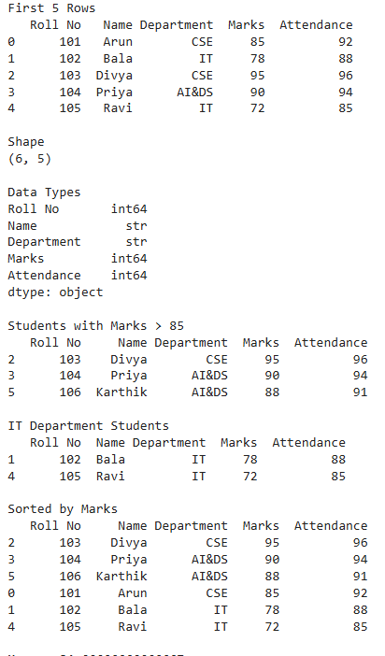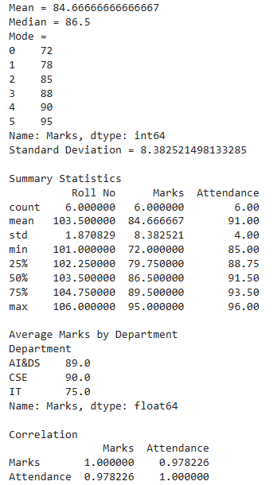
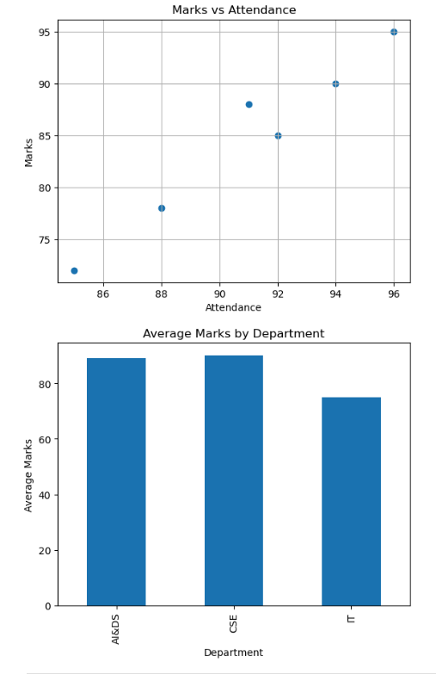

RESULT:
Thus, data inspection, filtering, sorting, descriptive statistical analysis, grouping, aggregation, and correlation analysis were successfully performed using Pandas. The analytical results were visualized and interpreted successfully.

